GIGS project - International Multiplier 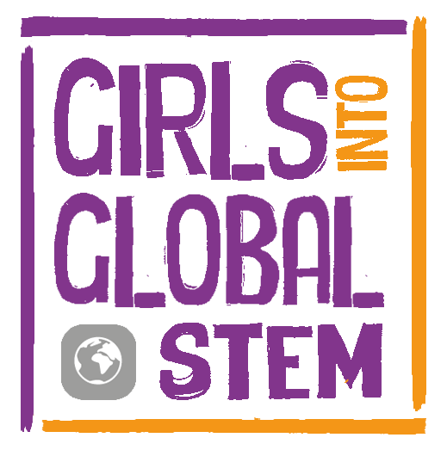

Location: University of Nicosia, Cyprus (16-17 May 2019)

Aims:
To share the methodologies and findings of the GIGS project and encourage wider uptake of GIGS resources and approaches.
Event objectives:
  - Day 1 (10.30 – 4.00) will be about the project with workshops and presentations to help participants choose for Day 2
  - Day 2 (09.00 – 3.30) will be focussed on individual (or joint) project achievements
--------------------------------------------------------------------------------------------------------------------------
Outline of the programme:

Thursday 16th May
Registration and introductions
Keynote speaker Day 1: Policy maker/leading academic in STEM

Outline of the GIGS project: methodology, partners, aims, outputs, brief research findings
How each partner country contributed to the project
‘Getting to know you’ activity
Workshop 1:
Global Issues and GIGS: The benefits of using real world contexts in STEM teaching
- Global Links, using resources as a springboard to activities in the classroom and embedding the Global Goals in the curriculum

Workshop 2:
Research into Girls and STEM (in mixed groups):
- Digital collaboration: what preconceptions do delegates have about issues of Girls & STEM?
- Sharing the findings of our Systematic Literature review
Preparatory sessions for Day 2:
i) Intergenerational/Co-Creation with the student eBook creators: Develop questions for student interviews
ii). Documenting progress in a project by means of blogging (and having your pupils do the same

Lunch break

A live video conference session with a group of students, answering questions from delegates

Workshop 3:
- The chance to try some hands-on activity developed during our GIGS project

Round up plenary and finish for the day
--------------------------------------------------------------------------------------------------------------------------
Friday 17th May

Keynote speakers Day 2: Exemplar women with STEM-based careers

Interactive follow up to sessions initiated in Day 1:
i). Intergenerational/Co-Creation with the student eBook creators
ii). Documenting progress in a project by means of blogging

Workshops from country teams:
Workshop 4 (Poland):
Center for Citizenship Education Foundation (CCE) and Zespół Szkół w Siennicy
- Gender issues in the context of Global Challenges
- The perspective of CCE and Zespół Szkół w Siennicy – what did we create and what impact did it have on CCE, our partner school, their pupils and staff

Workshop 5 (Sweden):
- Case study from University of Borås and Sandgärdskolan
- Creating eBooks together

Lunch

Workshop 6 (UK):

- The Drone Challenge: Coding and drones with a global context
- Using drones in STEM investigations - mapping onto key curriculum areas
- Video interview/webchat with Maria Terzi (Kios, University of Cyprus) about her work with drones and her career/inspiration
The GIGS online course and other project resources

Evaluation and next steps

